Design UI/UX
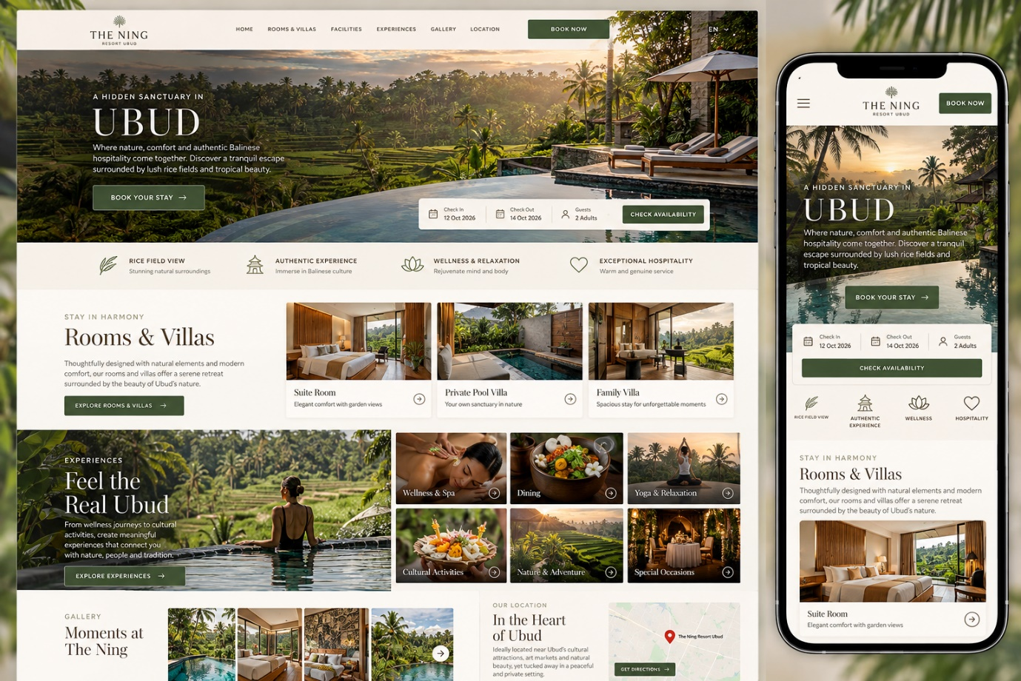
HEADER
Logo – Nav Menu – Book Now
NAVIGASI MENU
- Home
- Rooms & Villas
- Offers
- Dinning
- Wellness
- Activities
- Wedding
- About Us

Home
Hero Section
Slide 5 images
Introduction Section
Luxury Resort in Ubud Bali offering private pool villas, rice field views, jungle view and unforgettable honeymoon experiences.
Located just 15 minutes from Ubud Center, our resort combines modern elegance with authentic Balinese hospitality for an unforgettable island escape.
As one of the most peaceful private resorts in Ubud, The Ning Resort Ubud features spacious luxury rooms, premium amenities, and personalized service designed for couples, families, honeymooners and travelers seeking a romantic getaway in Ubud.
Indulge in world-class dining, rejuvenating spa treatments, and tranquil wellness experiences at our resort. Whether you are looking for Ubud accommodation for a honeymoon, relaxation retreat, or luxury Bali holiday, The Ning Resort Ubud is your sanctuary of comfort, privacy, and unforgettable memories in Ubud, Bali.
Room & Villas Section
Carosoul Slides Room Category With Short Description View Details
- Suite With Balcony
- Deluxe Suite With Balcony
- One-Bedroom Plunge Pool Villa
- One-Bedroom Pool Villa
- One-Bedroom Pool Villa With Living Room
- Two-Bedroom Duplex Pool Villa
- Residential Suite Two-Bedrooms With Balcony

EXPERIENCES
- Frangipani Spa View Details Open page
- Orchid Restaurant & Rose Bar View Details Open page
- Lotus Gym View Details Open page
- Infinity Pool View Details Open page
- Yoga Shala View Details Open page

Location:
Google map

Note Setiap nav menu di buatkan file .html baru

